Candlelight Christian Fellowship
Hebrews (Chapter 1 – Lesson 2)

Hebrews 1 (NKJV)

“God, who at various times and in various ways spoke in time past to the fathers by the prophets, has in these last days spoken to us by His Son, whom He has appointed heir of all things, through whom also He made the worlds; who being the brightness of His glory and the express image of His person, and upholding all things by the word of His power, when He had by Himself purged our sins, sat down at the right hand of the Majesty on high, having become so much better than the angels, as He has by inheritance obtained a more excellent name than they. For to which of the angels did He ever say: ‘You are My Son, today I have begotten You’? And again: ‘I will be to Him a Father, and He shall be to Me a Son’? But when He again brings the firstborn into the world, He says: ‘Let all the angels of God worship Him.’ And of the angels He says: ‘Who makes His angels spirits and His ministers a flame of fire.’ But to the Son He says: ‘Your throne, O God, is forever and ever; a scepter of righteousness is the scepter of Your kingdom. You have loved righteousness and hated lawlessness; therefore God, Your God, has anointed You with the oil of gladness more than Your companions.’ And: ‘You, Lord, in the beginning laid the foundation of the earth, and the heavens are the work of Your hands. They will perish, but You remain; and they will all grow old like a garment; like a cloak You will fold them up, and they will be changed. But You are the same, and Your years will not fail.’ But to which of the angels has He ever said: ‘Sit at My right hand, till I make Your enemies Your footstool’? Are they not all ministering spirits sent forth to minister for those who will inherit salvation?”

The Triune Nature of God

Religious leaders and scholars have debated what Christians call the doctrine of the Trinity. The teaching asserts that there is only one God and that He has revealed Himself as the personal, transcendent, eternal, sovereign Creator of all things. He is the first and last, the only Savior and Lord; there is no other. He is eternally self-existent and has revealed Himself as a Tri-unity of three persons: Father, Son, and Holy Spirit (three persons, yet one God).

Among the many aberrant teachings about the Trinity, we find these common errors:

1) That God is a Tri-unity of three personalities—not persons.
2) That Jesus is not God but is a lesser god—a created being.
3) That there are many gods.
4) That the Holy Spirit is not a distinct member of the Godhead but a force or energy.
5) That Jesus is the Father, Son and Holy Spirit.

In defense of the positions we hold as biblical, let’s look at three basic points:

1) The Scriptures Teach that There is Only One God and that He is the Father

Within the Scriptures God asks the following question: "To whom will you liken me, and make me equal, and compare me, that we may be like?” He then answers, “I am God, and there is no other; I am God, and there is none like me" (Isaiah 46:9). He said, "Before Me there was no God formed, nor shall there be after me" (Isaiah 43:10b), and, "I am the first, and I am the last; besides me there is no God" (Isaiah 44:6).
Jesus taught His disciples to pray using these words, “Our Father in heaven, hallowed be Your name” (Matthew 6:9). Paul when writing to the Ephesians declared that there is “One God and Father of all, who is above all…” (Ephesians 4:6).
With this small sampling of just a few verses, we can see that there is only one God and that He is referred to as “Father.”

2) The Bible Teaches that Jesus is God, the Son of the Father

Jesus Christ is the only begotten Son of God (see John 3:16). He Himself is God incarnate (in flesh) and in Him the fullness of the Godhead dwells—and is revealed to man. “For in Him dwells all the fullness of the Godhead bodily” (Colossians 2:9).
John when writing his gospel explained to his readers, “In the beginning was the Word, and the Word was with God, and the Word was God. He was in the beginning with God. All things were made through Him, and without Him nothing was made that was made. In him was life; and the life was the light of men (1:1–4)….the Word was made flesh, and dwelt among us, and we beheld His glory, the glory as of the only begotten of the Father, full of grace and truth” (1:14).
As stated above, Isaiah recorded God saying, "I am the first, and I am the last; and beside me there is no God" (Isaiah 44:6). However, Jesus, when speaking to John in the book of Revelation, said that He is the first and last. He said, “Do not be afraid; I am the First and the Last. I am He who lives, and was dead, and behold, I am alive forevermore. Amen” (Revelation 1:17b–18a).

A careful examination of these verses causes us to conclude that Jesus is either a liar, that God is a liar, or that Jesus is God: “the first and the last.”

Secondly, God tells us in the Old Testament that He is the only Savior. He said, “You are my witnesses,” says the LORD, “and my servant whom I have chosen: that you may know and believe me, and understand that I am He: before me there was no God formed, neither shall there be after me. I, even I, am the LORD; and besides me there is no Savior” (Isaiah 43:10–11).
In the New Testament letter to Titus, Paul called Jesus the Savior. He wrote that we are, “looking for the blessed hope and glorious appearing of our great God and Savior Jesus Christ, who gave Himself for us, that He might redeem us” (Titus 2:13–14).
Peter called Jesus the Savior when he wrote, “our Lord and Savior Jesus Christ” (2 Peter 1:11). He also said we are to “grow in grace, and in the knowledge of our Lord and Savior Jesus Christ. To Him be the glory both now and forever. Amen” (2 Peter 3:18).
John called Jesus the Savior. He wrote, “And we have seen and do testify that the Father sent the Son to be the Savior of the world” (1 John 4:14).

Just as earlier identified, if we carefully compare these verses, we are forced to conclude that either God was lying; Paul, Peter, and John were lying; or that Jesus is the one and only true and living God, the Savior of the world.

3) The Bible teaches that the Holy Spirit is God.

When Jesus was publicly baptized, an interesting series of events occurred. Matthew records, “When He had been baptized, Jesus came up immediately from the water; and behold, the heavens were opened to Him, and He saw the Spirit of God descending like a dove and alighting upon Him. And suddenly a voice came from heaven, saying, ‘This is My beloved Son, in whom I am well pleased’” (Matthew 4:16–17).

Please note here the presence of Jesus (the Son who was being baptized), the Father (Who spoke from heaven), and the Holy Spirit (Who descended like a dove). In this passage alone, we see all three members of the Godhead.

Secondly, we see the Holy Spirit referred to as God when Peter was questioning Ananias and Sapphira. Following a carefully planned act of deception, Peter said, “Ananias, why has Satan filled your heart to lie to the Holy Spirit.” He continued, “Why have you conceived this thing in your heart? You have not lied to men but to God” (Acts 5:1–4). Clearly, Peter refers to the Holy Spirit as God.

The Three in One! One God – Three Persons!

The three short sections above should be enough to support the further truth found in John’s epistle, where he wrote, “For there are three that bear witness in heaven: the Father, the Word, and the Holy Spirit; and these three are one” (1 John 5:7).

All this is to say that, “God, who at various times and in various ways spoke in time past to the fathers by the prophets, [but] has in these last days spoken to us by His Son” (vs. 2), and that His Son, is the promised Messiah, Immanuel, God incarnate, as promised to all the “fathers” through the prophets, and testified to in the law. He is God the Son!

Read: Matthew 3

Notes:

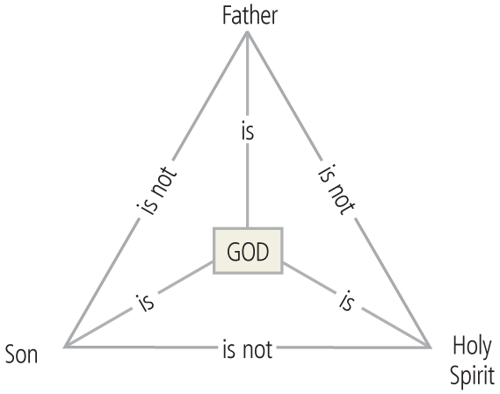

Questions:

- True or False: Religious leaders and scholars have no problems understanding the doctrine of the Trinity.
- True or False: He is eternally self-existent and has revealed Himself as a Tri-unity of three persons: Father, Son, and Holy Spirit (three persons, yet one God).
- True or False: God is a Tri-unity of three personalities.
- True or False: Jesus is God and prayed to Himself when He was in the Garden and on the Cross.
- True or False: The Holy Spirit is not a distinct member of the Godhead but a force or energy.
- True or False: Jesus is the Father, Son and Holy Spirit.
- True or False: The Bible refers to the God as the Father.
- True or False: The whole of Scriptures causes us to believe that Jesus is the one and only true and living God—incarnate; Savior of the world.
- True or False: The Holy Spirit was referred to as God when Peter addressed Ananias and Sapphira.
- True or False: There are three that bear witness in heaven: the Father, the Word, and the Holy Spirit; and these three are one.

